**Set Tayo Ng Date**

Use Case Specification

Submitted to:

Asst. Prof. Ma. Rowena C. Solamo

Faculty Member

Department of Computer Science

College of Engineering

University of the Philippines, Diliman

Submitted by:

Bandong, Arvin

Bariring, Edward James

Rosales, Kyle

In partial fulfillment of academic requirements

for the course

CS 191 Software Engineering I

of the

1st Semester, AY <2016-2017>

***Unique Reference:***

The documents are stored in the <https://github.com/DarkPotatoKing/cs-191-192-repo>

***Document Purpose:***

The purpose of this document is to describe what happens when a user tries to delete an existing or non-existing schedule table of a certain person.

***Target Audience:***

The target audience for this document is the user who wants to delete a certain schedule table.

***Revision Control***

*History Revision:*

|  |  |  |  |
| --- | --- | --- | --- |
| ***Revision Date*** | ***Person Responsible*** | ***Version***  ***Number*** | ***Modification*** |
| 09/29/16 | Arvin Bandong | 1.0 | Initial Document |

*Use-Case Name*: Use-Case 1.3 Delete Schedule

*Description:* The user can delete any existing schedule table. He can either search the name of the person that he wishes to delete, or manually scan it from the list. After finding the desired schedule table, he can now click the "Delete" button and a confirmation message will appear. Deletion will proceed if "Yes" is selected and it will be canceled if "No" is selected.

*Preconditions:* There should be at least 1 schedule in the database to use Delete.

*Flow of Events:*

|  |  |
| --- | --- |
| ***Scenario Name*** | ***Description*** |
| Scenario 1 (Basic Flow)  User manually searches the table and confirms the deletion | 1. User picks a table that he wishes to delete.  2. User scans the list of tables until he finds the one he wishes to delete.  3. User should click the table of that person.  4. User clicks “Delete” button.  5. A confirmation message will flash.  6. User clicks “Yes” button.  7. A message indicating that deletion is complete will be shown. |
| Scenario 2  User manually searches the table and cancels the deletion | 1. User picks a table that he wishes to delete.  2. User scans the list of tables until he finds the one he wishes to delete.  3. User should click the table of that person.  4. User clicks “Delete” button.  5. A confirmation message will flash.  6. User clicks “No” button.  7. A message indicating that deletion is cancelled will be shown. |
| Scenario 3  User searches for a name and it is not in the database | 1. User picks a table that he wishes to delete.  2. User inputs the name of that person in the search bar.  3. A message indicating that no such name exists will be shown. |
| Scenario 4  User searches for a name that exists and decides to delete it | 1. User picks a table that he wishes to delete.  2. User inputs the name of that person in the search bar.  3. A list of tables that matches with the name being searched will be shown.  4. User should click the table of that specific person.  5. User clicks “Delete” button.  6. A confirmation message will flash.  7. User clicks “Yes” button.  8. A message indicating that deletion is complete will be shown. |
| Scenario 5  User searches for a name that exists and decides to cancel deletion | 1. User picks a table that he wishes to delete.  2. User inputs the name of that person in the search bar.  3. A list of tables that matches with the name being searched will be shown.  4. User should click the table of that specific person.  5. User clicks “Delete” button.  6. A confirmation message will flash.  7. User clicks “No” button.  8. A message indicating that deletion is cancelled will be shown. |

*Activity Diagram of the Flow of Events:*

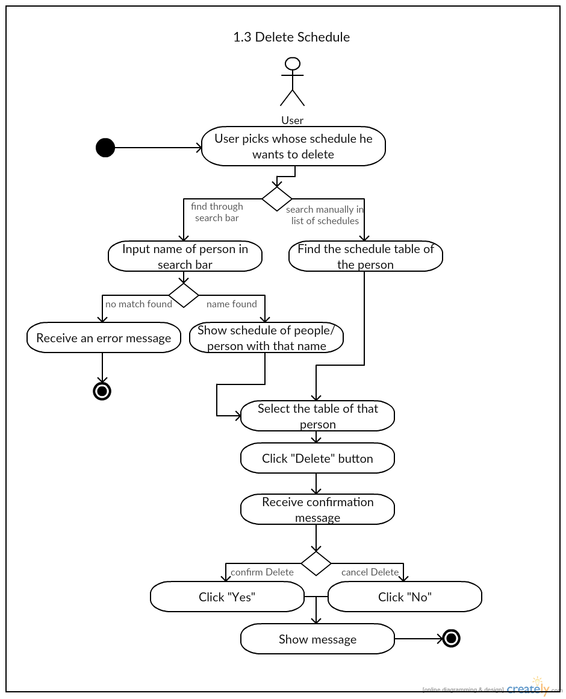

*Postcondition:* NONE

*Relationships:* NONE

*Special Requirements:* NONE